# Exercise: Introduction to Bootstrap

Problems for exercises and homework for the ["JavaScript For Front-End Course @ SoftUni"](https://softuni.bg/trainings/2032/javascript-for-front-end-july-2018#lesson-8965).

Archive your solutions and upload them in [course page](https://softuni.bg/trainings/2032/javascript-for-front-end-july-2018#lesson-8969).

# Bootstrap Website

## Overview

You have been tasked to create an entire website with **Bootstrap**.

You will be given the **images** and **text**.

You are **NOT** allowed to use jQuery or Bootstrap plugins, but you should write some custom **CSS**.

Your website should have **three pages** and navigation **between** them.

### Project Structure

Your **project structure** should look like this:

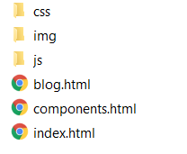

### Navigation Bar

The main **navigation bar**, contains **3 elements**, which should control your **movement** through the website’s **web** **pages**.

* [WELCOME TO BOOTSTRAP] – should redirect to **Home** page (index.html).
* [COMPONENTS] – should redirect to **Components** page (components.html).
* [BLOG] – should redirect to **Blog** page (blog.html).



### Home Page

The **home** **page** should look like this:

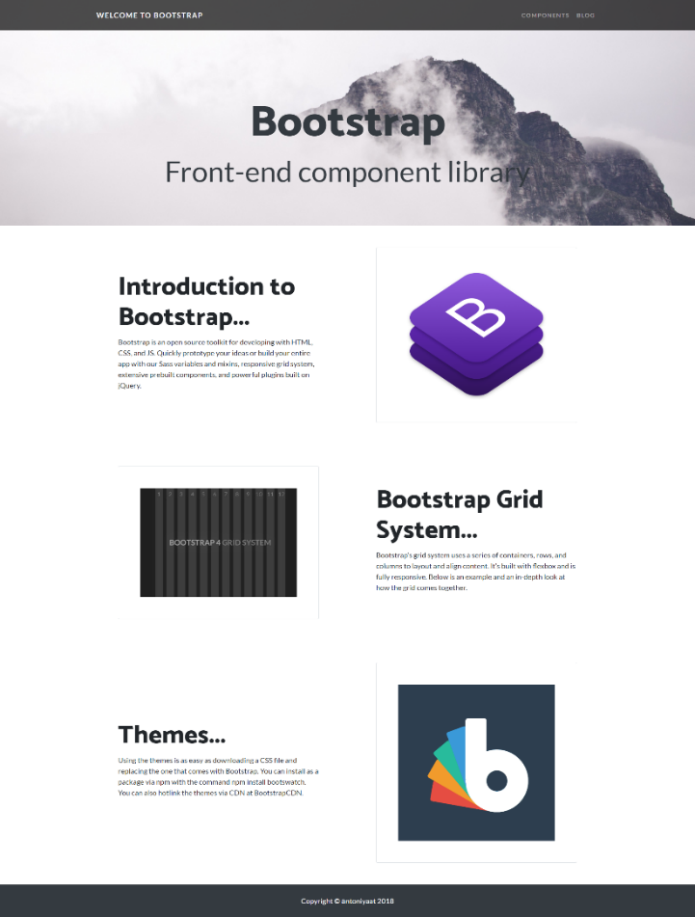

### Components Page

The **components** **page** should look like this:

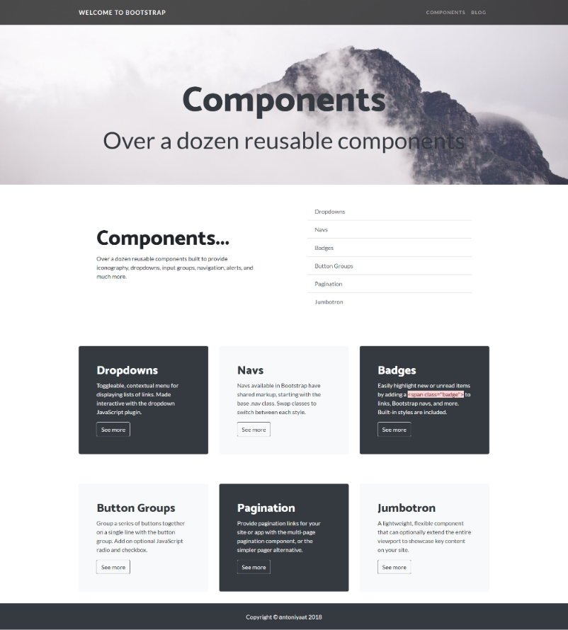

### Blog Page

The **blog** **page** should look like this:

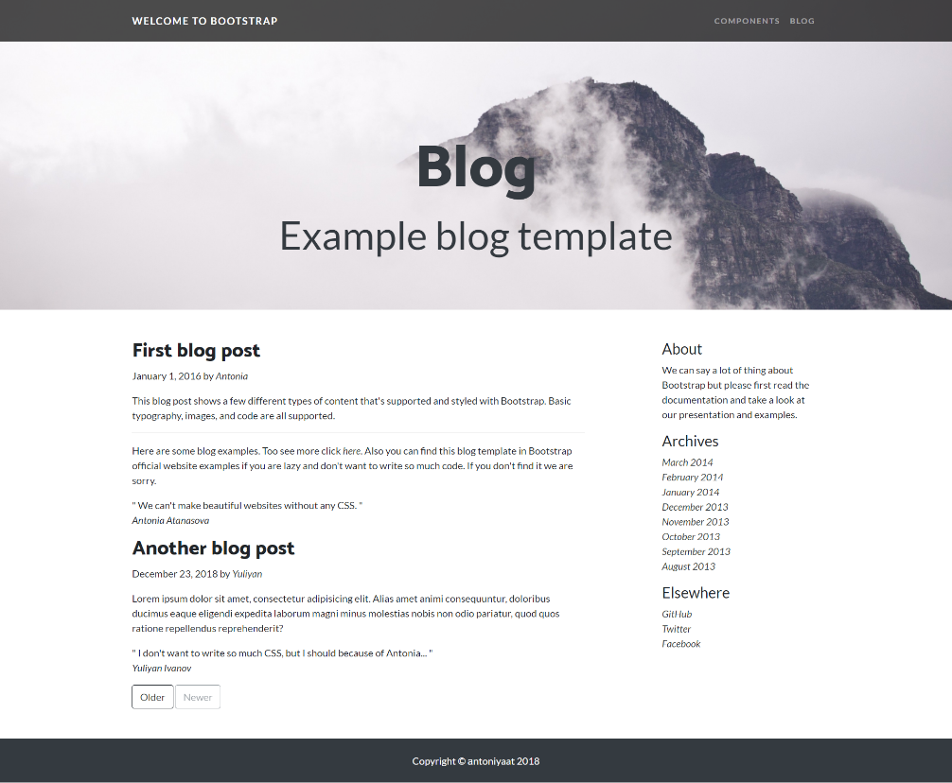

## Constraints:

* Use “Lato” for **main font** – <https://fonts.google.com/specimen/Lato?selection.family=Lato>
* Use “Catamaran” for **headings**  (**font-weight:800**) – <https://fonts.google.com/specimen/Catamaran?selection.family=Catamaran>
* Use background-color: **#343A40**
* Make sure that your website is **responsive**

## Hints:

* You can reuse **navigation bar** and **footer**
* You can search for **Blog** **Example** on **Bootstrap** official documentation
* Import **fonts** at custom **CSS** file
* Style heading with image for background in your **custom CSS**